

**NOTICE OF RACE**

**Wessex Region - Laser Grand Prix at Whitefriars Sailing Club**

**3 May 2025**

Lake 26, Cotswold Water Park, Ashton Keynes SN6 6QR

Email: [s](mailto:enquiries@earlswoodsc.co.uk)ailing@whitefriarssc.org

**1. Organising Authority**

The organising authority is Whitefriars Sailing Club.

**2. Rules**

2.1 All races will be governed by the rules as defined in The Racing Rules of Sailing 2025-2028

2.2 Competitors should note that Whitefriars Sailing Club implements the RYA Racing Charter and that they will be required to undertake to sail in compliance with the Charter, which can be found at the front of the RYA rule book (RYA Racing Rules of Sailing 2025-2028).

2.3 Racing rules 40, 35, A4 and A5 will be changed. The changes appear in full in the Sailing Instructions or in this Notice of Race.

2.4 Whitefriars Sailing Club operates a no smoking policy in the club house and compound which must be observed at all times. The use of vaping equipment/e-cigarettes/etc is prohibited under this policy.

2.5 Whitefriars Sailing Club rules state that dogs, brought on site, must be kept on a lead at all times, must not cause a nuisance and are not allowed in the Clubhouse.

2.6 Whitefriars Sailing Club requires that all children under the age of 10 must wear buoyancy aids whilst at the club unless inside the Clubhouse. Children under the age of 16 must be supervised by an adult at all times.

**3. Conditions of sailing and racing**

3.1 Entries by eligible boats should be made online at https://whitefriarssc.org. The entry fee for the event will be £15. Registration will commence from 1 April 2025.

3.2 All craft on the club premises (on land and on the water) must have full insurance cover, including third party liability to £3,000,000. All craft intended to be used for racing must include use for racing in their insurance cover.

3.3 The safety of the competitor’s boat and its entire management including insurance shall be the sole responsibility of the competitor(s) racing the boat.

3.4 The race organisers shall not be liable for any loss, damage, death or personal injury howsoever caused to the owner/competitor, his skipper or crew, as a result of their taking part in the race or races. Moreover, every owner/competitor warrants the suitability of his craft for the race or races.

3.5 To prevent the spread of non-native species there is a requirement to ensure that boats are clean before they visit the site using the principle of Check – Clean- Dry***.*** See <http://www.nonnativespecies.org/checkcleandry/index.cfm>. There is a boat wash station at the entry to the car park.

3.6 The Exoneration Penalty and the Advisory Hearing and RYA Arbitration of the RYA Rules Dispute Procedures will be available. Decisions from RYA Arbitration can be referred to a protest committee but cannot be reopened or appealed.

**4. Event and Programme**

4.1 Whitefriars Sailing Club will be open to receive visiting competitors from 9 am on the day of the event.

4.2 There will be a briefing for all competitors no earlier than 10.30 on Saturday 13 April 2024 and the prize giving will be held after the final race.

4.3 It is intended there will be 4 races. The warning signal for the first race shall be no earlier than 10.55 on Saturday 13 April 2024

4.5 The race starting sequence shall be as defined in the Whitefriars ‘Sailing Instructions for Open Meetings’

**5. Sailing Instructions**   
Sailing instructions will be available online and are posted on the official race notice board in the clubhouse.

**6. Course**   
The course will be set on Whitefriars Sailing Club water. The course will be posted on the committee boat and/or race hut.

**7. Scoring**The number of results that will be used to determine a boats series score will be as follows:-

* 4 races completed, 3 results to count
* 3 or 2 races completed, 2 results will count
* A minimum of 2 races constitutes a series

**8. Personal Buoyancy Flotation Devices**   
Adequate personal flotation devices for helm/crew members shall be worn at all times. Wet suits and dry suits are not personal flotation devices. This changes Rule 40.

**9. Scoring**

9.1 Points

The low point scoring system will apply as set out in RRS A4. Boats that did not start, did not finish, retired after finishing or were disqualified shall be scored in accordance with RRS A4.

9.2 Series Ties

RRS rule A8 applies.

9.3 Individual Scoring

Boats will be placed in order of their combined points from all races in the series.

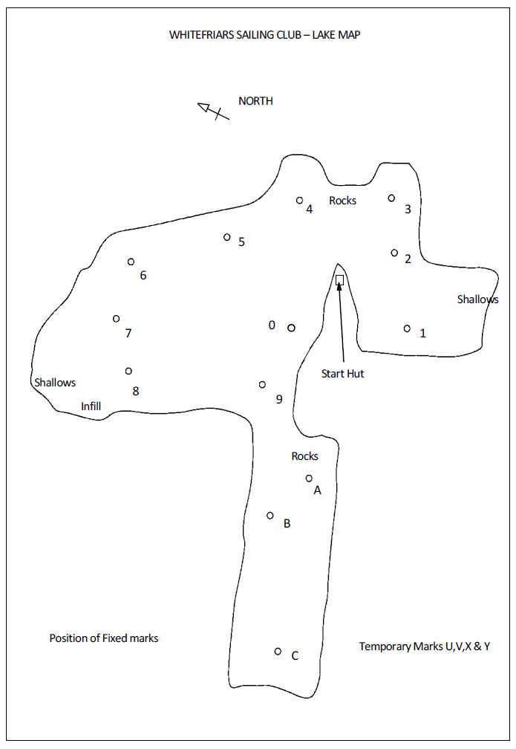**10. Advertising and Sponsorship**Advertising will be restricted to Category C.

**11**. **Racing Area** Plan view of Whitefriars Sailing Club water

# 12. Further Information

Whitefriars Sailing Club is situated at Lake 26, Cotswold Water Park, Ashton Keynes SN6 6QR

Club entrance located at grid reference SU 042 952 (nearest post code SN6 6QX)

Club phone number (for event) 01285 861670

For further information please contact:-

Dave Kelly 07798 678 567 or dkellygb@pm.me.